MECH 463 - Lab Report #2

Multi-DOF Vibration Measurement of a Simulated Engine Mounting

**Submitted: November 25, 2019**

**Group 105**

**Ahmad Farhan - 22426150**

**Arjun Vadehra - 20037164**

**Gianni Co - 16131161**

*Group Member Contribution:*

*Ahmad: 33.3%, Arjun: 33.3%, Gianni: 33.3%*

# Abstract

Vibrations are prevalent in most mechanical systems. There are good and bad vibrations which is why identification and characterization of systems with vibration is essential for engineers. In this experiment a 1-DOF forced damped spring mass system was analyzed to identify how vibration amplitude and phase change with forcing frequency, along with identifying the natural frequency and damping factor. The models were plotted against the collected data and differentiated between theoretical and experimental data. The 4 counter rotated wheels with varying frequency induced the driving force. Amplitude was calculated at each frequency. Due to a combination of systematic error from the measurement tool offset, over-idealization of the system, and resolution of positing the measurement probes, the recorded amplitude was smaller than the theoretical values. In 4 degrees of freedom (Z-Translation, X-, Y-, Z-Rotation), the resonant frequency, and amplitude was found by rearranging the eccentric masses.

The natural frequency and damping factors were characterized by striking the system with a mallet (in the X and Y directions) and observing the decaying and vibrating properties. Logarithmic decrement theory was employed to create a model for identifying the damping factor of the free underdamped system. The resonant frequencies and amplitudes at these frequencies were found as well. Following this several methods of identifying the damped natural frequency were compared, and the best method identified. Both the natural frequency and damped response of the system matched very closely with the theory with the exception of one point which is suspected to be human error. Overall the experiment verifies the accuracy of theory for simple vibrating systems.

# Introduction and Methodology

Following from the previous report, the (generally) undesirable nature of vibrations in mechanical systems has been well established. To further our understanding of vibration in the design of systems, this lab focuses on the multi-DOF aspect of vibrational response. The objective of this Lab was to conduct a comprehensive analysis of the vibration response of a rotating system with eccentric masses providing excitation. In particular, observing the various natural frequencies and mode shapes associated with the 6 degrees of freedom of the apparatus.

The apparatus consisted of a frame supported by 4 springs and a damper, which houses to counter-rotating shafts with 4 eccentric masses on said shafts. By varying the position and frequency of rotation of the masses, different modes and frequencies can be excited. Accelerometers were positioned based on the DOF being analyzed and recorded respective responses.

While the previous Lab procedure was limited to the single-DOF analysis, there is consideration for all 6 DOF’s in this report. The arrangement and apparatus used for each DOF is outlined below

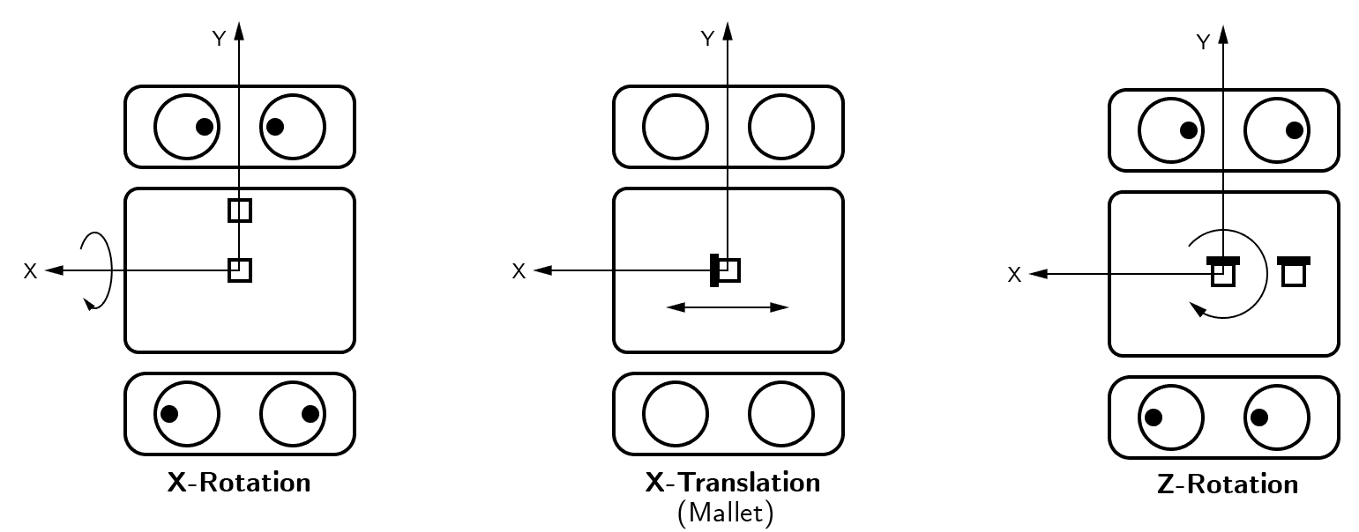

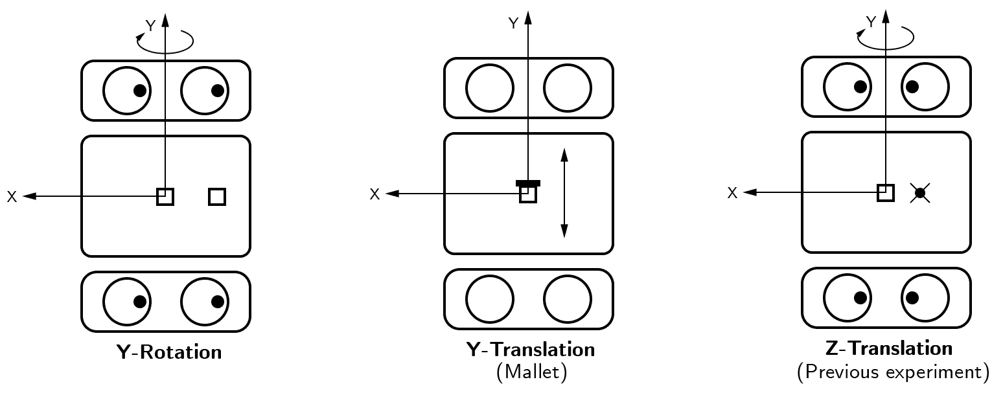

# Results

## Translational responses

For the x,y and z translation responses, the amplitude vs frequency plots were created (See figures 1,2 and 3). The plots represent the response recorded by the accelerometers after the apparatus was struck in the desired direction with the mallet. The figures are the FFT diagrams recorded using LABview.

The following relation was used to convert the voltage recordings to amplitude in meters.

Please note that data from Lab 1 was reutilized for the z translational plot (Refer report 1).

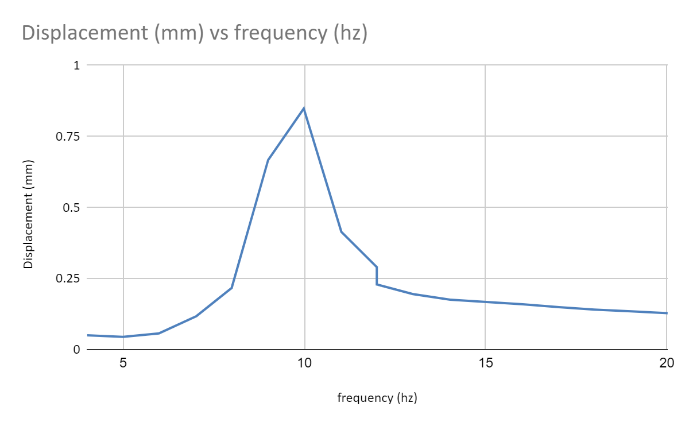

*Figure 1: Z-translation response - see report 1*

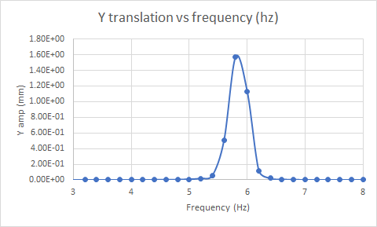

*Figure 2: Y-translation response*

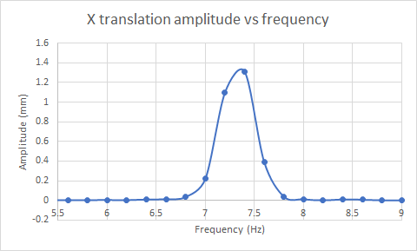

*Figure 3: X-translation response*

## Rotary responses

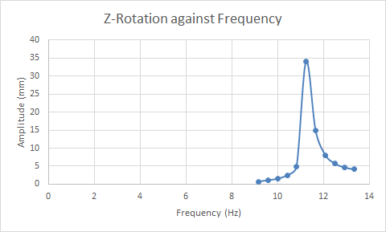

*Figure 4: Z-Rotation response*

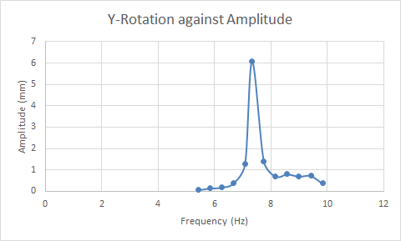

*Figure 5: Y-Rotation response*

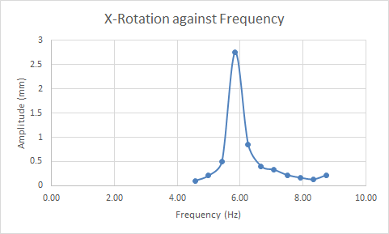

*Figure 6: X-Rotation response*

## Mallet impact responses

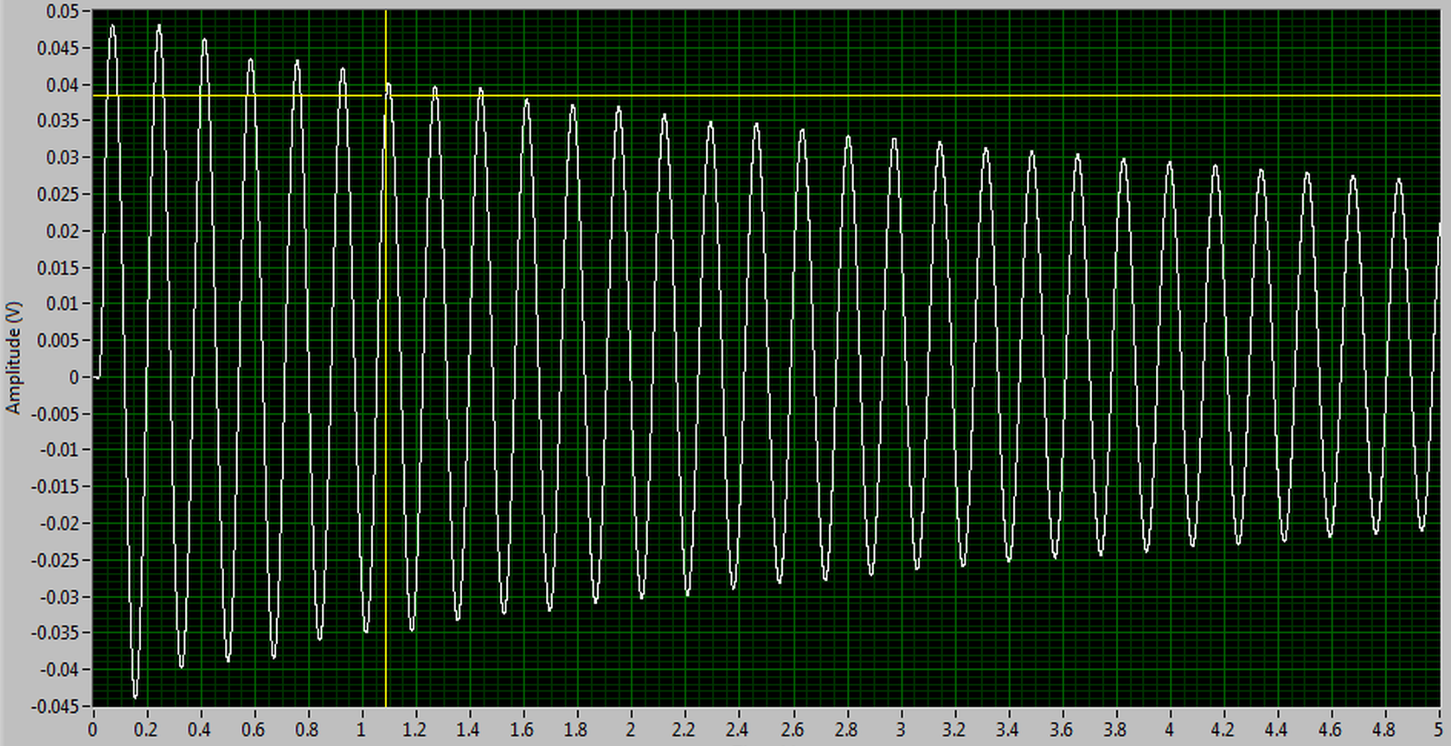

*Figure 7: Vibration curve from Y-Translation using the mallet*

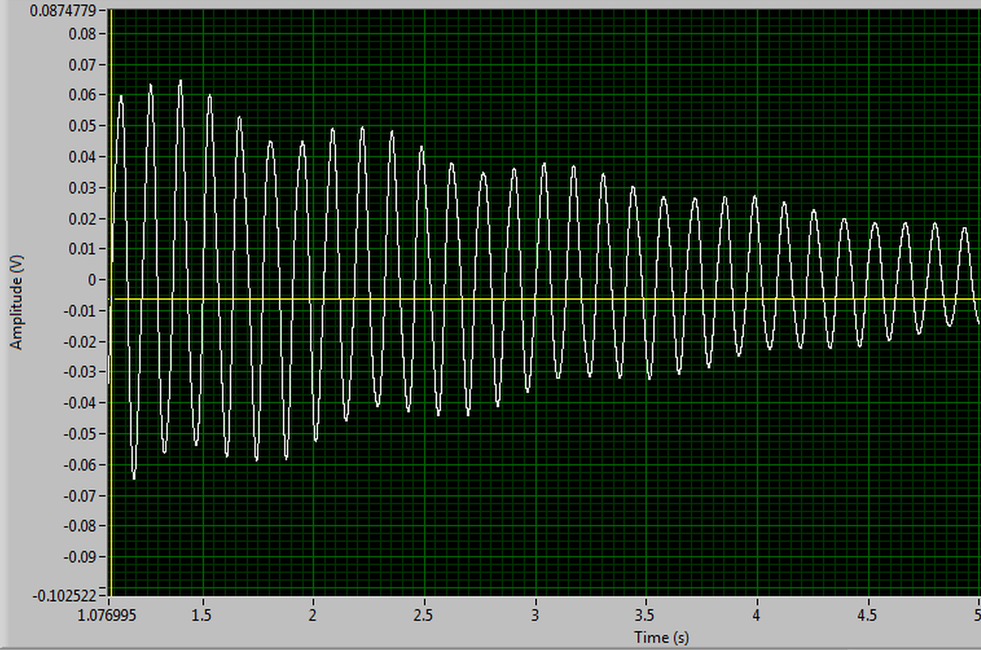

*Figure 8: Vibration curve from X-Translation using the mallet*

# Discussion

## Insert section name here

## Damping Factor Calculation

The damping factor of the system (engine block simulation) was determined in the second section of our experiment by first turning off the rotating eccentric masses (f(t) = 0). We then smacked the setup with the soft end of a rubber mallet. The resulting waveform, as shown in Figure xx below, was recorded by the accelerometer. We used the method of logarithmic decrements and rate of decay of each peak to calculate for the damping factor.

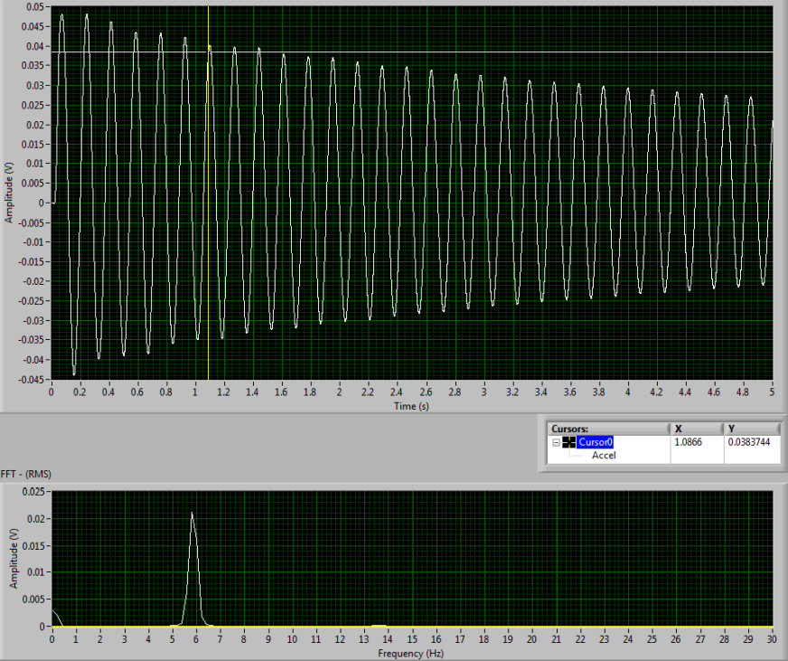

*Figure xx: Raw accelerometer waveform data from the Y-Translation mallet test*

The logarithmic decrement method uses the following equations below:

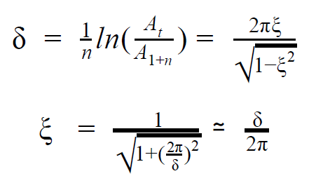

We can then pull the peaks of the accelerometer output and compare their rates of decay as time goes on and the number of waveforms increase. The relationship observed experimentally closely matches theoretical expectations. We skipped the first pairs of peaks (n=0, n=0.5) due to an abnormality in the first negative peak (this is shortly after the mallet struck). A table of these values are shown below.

*Table xx: Vibration peaks when hit by mallet in the Y direction*

|  |  |  |  |  |
| --- | --- | --- | --- | --- |
| Time | Peak Number | Amplitude (mm) | ln(amplitude) | Log decrement |
| 0.00 | 1 | 4.90 | 1.59 | 0.000 |
| 0.17 | 2 | 4.80 | 1.57 | 0.013 |
| 0.34 | 3 | 4.60 | 1.53 | 0.028 |
| 0.51 | 4 | 4.40 | 1.48 | 0.030 |
| 0.69 | 5 | 4.40 | 1.48 | 0.000 |
| 0.86 | 6 | 4.30 | 1.46 | 0.016 |
| 1.03 | 7 | 4.00 | 1.39 | 0.051 |
| 1.20 | 8 | 4.00 | 1.39 | 0.000 |
| 1.37 | 9 | 4.00 | 1.39 | 0.000 |
| 1.54 | 10 | 3.80 | 1.34 | 0.038 |
| 1.71 | 11 | 3.70 | 1.31 | 0.020 |
| 1.89 | 12 | 3.70 | 1.31 | 0.000 |
| 2.06 | 13 | 3.60 | 1.28 | 0.021 |
| 2.23 | 14 | 3.50 | 1.25 | 0.022 |
| 2.40 | 15 | 3.50 | 1.25 | 0.000 |
| 2.57 | 16 | 3.40 | 1.22 | 0.023 |
| 2.74 | 17 | 3.30 | 1.19 | 0.025 |
| 2.91 | 18 | 3.30 | 1.19 | 0.000 |
| 3.09 | 19 | 3.20 | 1.16 | 0.026 |
| 3.26 | 20 | 3.10 | 1.13 | 0.028 |
| 3.43 | 21 | 3.10 | 1.13 | 0.000 |
| 3.60 | 22 | 3.00 | 1.10 | 0.029 |
| 3.77 | 23 | 3.00 | 1.10 | 0.000 |
| 3.94 | 24 | 2.90 | 1.06 | 0.031 |
| 4.11 | 25 | 2.90 | 1.06 | 0.000 |
| 4.29 | 26 | 2.80 | 1.03 | 0.034 |
| 4.46 | 27 | 2.80 | 1.03 | 0.000 |
| 4.63 | 28 | 2.70 | 0.99 | 0.036 |

A logarithmic plot of amplitude against peak/waveform number has been plotted below based on Table xx above (Figure xx).

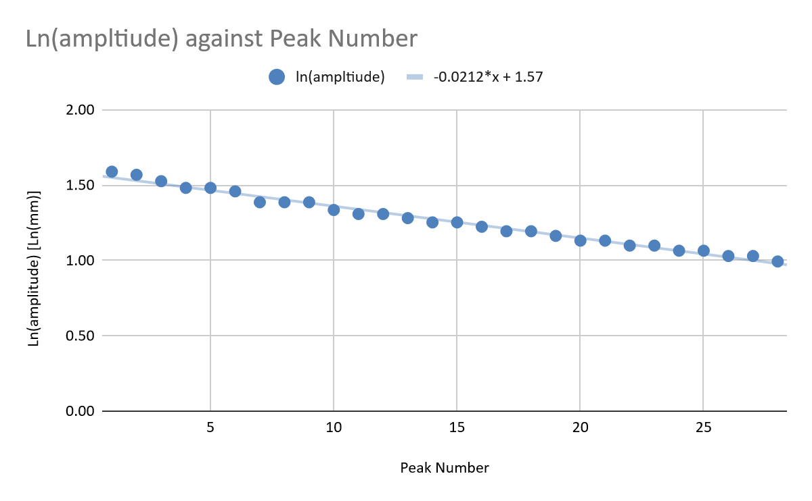

*Figure xx: Logarithmic plot of amplitude against peak number*

We can convert the average logarithmic decrement of the plot (0.0212, slope*-1) into the damping factor of the system using one of the equations shown above. The damping factor is calculated to be .

Using the same methods outlined above, the damping factors for X-Translation and Z-Translation were calculated to be and , respectively. These results appear to make sense. The vibrational damping in the Y direction is the least since it’s on the ‘short’ side of the simulated engine block. This is followed by damping in the X direction, or the ‘long’ side and finally followed by the Z direction, which actually has a dashpot in it’s direction.

# Conclusions

Table xx: Summary of results for resonant frequency and amplitude in different DOF’s

|  |  |  |
| --- | --- | --- |
| **Degree of Freedom** | **Resonant Frequency (Hz)** | **Amplitude at Resonance (mm)** |
| X-Translation | 7.40 | 2.8 |
| Y-Translation | 5.80 | 2.1 |
| Z-Translation | 10 | 8 |
| X-Rotation | 5.83 | 2.75 |
| Y-Rotation | 7.33 | 6.08 |
| Z-Rotation | 11.25 | 34.0 |

Table xx: Damping constants in different DOF’s

|  |  |
| --- | --- |
| **Degree of Freedom** | Damping constant |
| X-Translation | 0.0112 |
| Y-Translation | 0.00337 |
| Z-Translation | 0.032 |